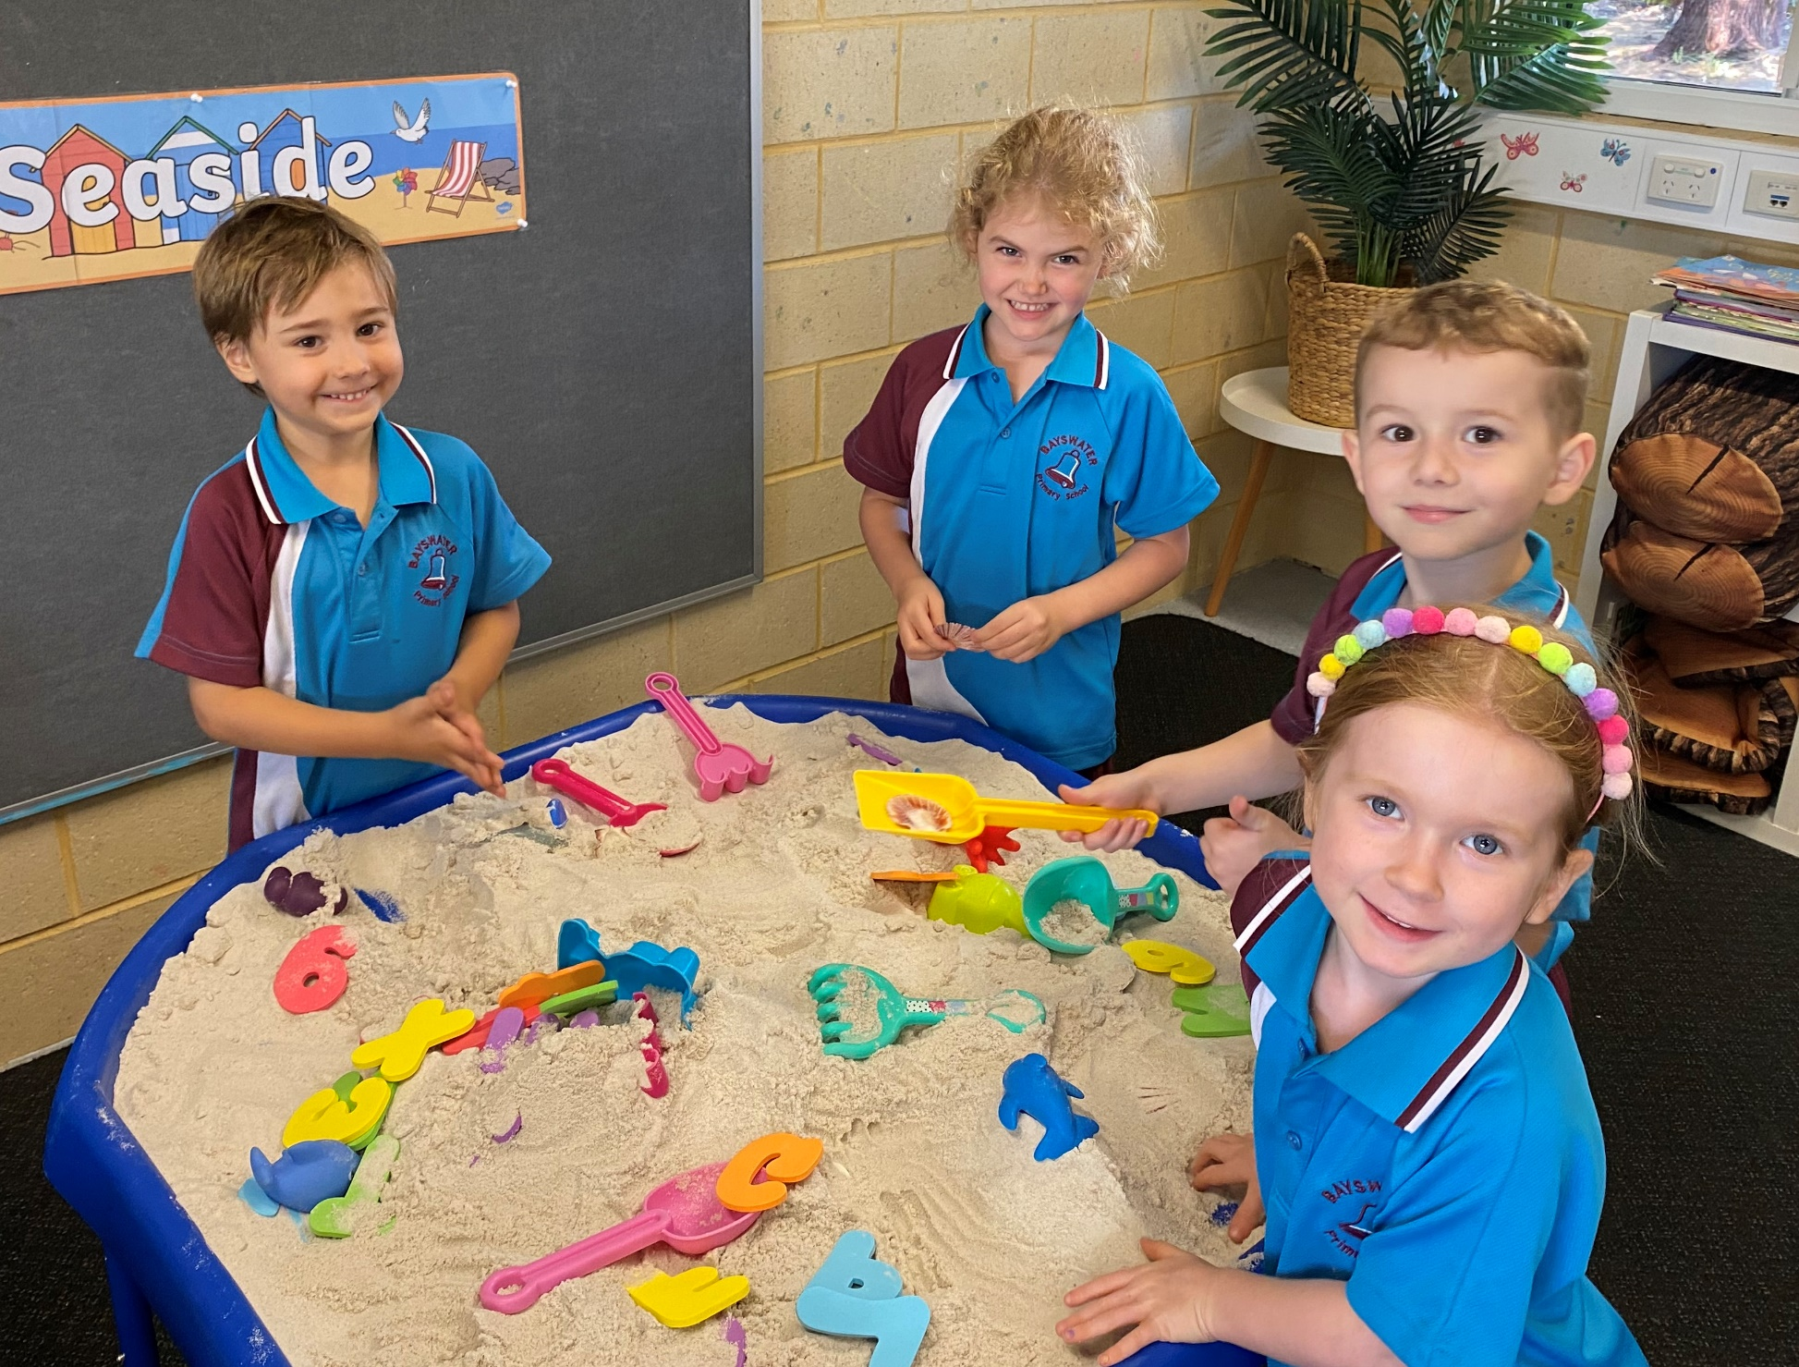




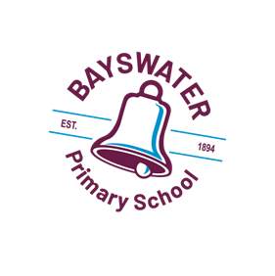
Kindergarten
Parent
Handbook
2026

Welcome
Starting Kindergarten is a significant milestone for both you and your child, marking the beginning of a new phase in your lives. The early years of school will be filled with excitement and engagement, and this booklet aims to ensure that your experience at Bayswater Primary School is as smooth and enjoyable as possible.

Our Kindergarten program is built on the foundations of the Early Years Learning Framework and the Kindergarten Guidelines. We provide a balanced teaching and learning environment that combines intentional play-based learning with explicit instruction in literacy and numeracy skills. Our goal is to foster trusting, respectful, and caring relationships with each child and their family.

Our Early Childhood philosophy is:
At Bayswater Primary, we value our community and work in partnership with families to support each child's learning, wellbeing, and independence. We believe that children thrive in a purposeful learning environment that responds to their interests, strengths, and needs. Our teaching programs balance explicit instruction with meaningful play and inquiry-based learning experiences, nurturing confident, curious, and successful lifelong learners.

Your child and family are important new members of our school community. Welcome to Bayswater Primary School!

First Day of Attendance for 2026
Blue and Green Group: Monday 2 February, 2026
Red and Orange Group: Thursday 5 February, 2026

Kindergarten Attendance Schedule
Students in the Monday/Tuesday Green Kindergarten Group and Blue Kindergarten Group will attend school every Monday and Tuesday and every odd school week Wednesday. Students in the Thursday/Friday Orange Kindergarten Group and Red Kindergarten Group will attend school every Thursday and Friday and every even school week Wednesday.
The scheduled alternate Wednesday’s attendance days for each Kindergarten Group are below.
 | Monday & Tuesday Groups - Blue ECE 4 and Green ECE 3
 | Term 1 | Term 2 | Term 3 | Term 4
Week 1 | Wed 4 Feb | Wed 22 Apr | Wed 22 Jul | Wed 14 Oct
Week 3 | Wed 18 Feb | Wed 6 May | Wed 5 Aug | Wed 28 Oct
Week 5 | Wed 4 Mar | Wed 20 May | Wed 19 Aug | Wed 11 Nov
Week 7 | Wed 18 Mar | Wed 3 June | Wed 2 Sep | Wed 25 Nov
Week 9 | Wed 1 Apr | Wed 17 Jun | Wed 16 Sep | Wed 9 Dec
Week 11 |  | Wed 1 Jul
 | Thursday & Friday Groups – Red ECE 4 and Orange ECE 3
 | Term 1 | Term 2 | Term 3 | Term 4
Week 2 | Wed 11 Feb | Wed 29 Apr | Wed 29 Jul | Wed 21 Oct
Week 4 | Wed 25 Feb | Wed 13 May | Wed 12 Aug | Wed 4 Nov
Week 6 | Wed 12 Mar | Wed 27 May | Wed 26 Aug | Wed 18 Nov
Week 8 | Wed 25 Mar | Wed 10 Jun | Wed 9 Sep | Wed 2 Dec
Week 10 |  | Wed 24 Jun | Wed 23 Sep | Wed 16 Dec

Preparing Your Child for Their First Day
It may help to begin moving to a 'school time' routine a few days before school starts, such as waking at a set time and going to bed a bit earlier. It may also help to start talking about school and what they may learn about or play with and how to interact with new friends. Some children may be nervous or scared about a new environment and others may be excited about the challenge.
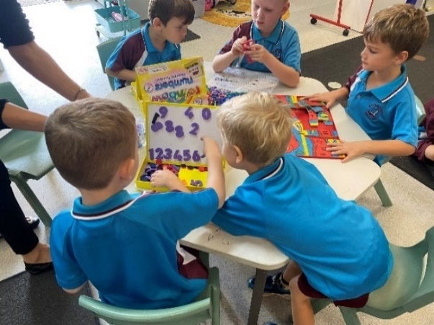
Before the first day of school, it would help if you practised with your child the skills involved in;
- Putting on and taking off clothes and shoes,
- Eating and drinking without help,
- Using a tissue,
- Flushing the toilet and using toilet paper without help,
- Washing hands after going to the toilet,
- Asking clearly for things that they need,
- Putting away books and toys after playing,
- Opening and closing their school bag and lunchbox,
- Helping with small jobs and following simple instructions,
- Applying Sunscreen.

Day One Procedure
Classroom doors will open at 8.40am for students to enter the classroom. When you arrive at school on the first day, we have hooks outside the classroom where students leave their school bags. Look for your child's name and place their school bag on the hook. Please then bring your child's labelled water bottle and a labelled piece of fruit or vegetables for 'crunch and sip' into the classroom.
There will be marked areas for you to place these. We have a small break in the morning for a healthy snack and drink which is what we call 'crunch and sip' time. We also have a time to eat at recess, and then lunch. If you have your child's school supplies, please bring them into the classroom. There will be a name tag available for you to put on your child. Please then come and introduce yourselves to the teaching staff. We will be endeavouring to move around to welcome all students and their families.
There will be tabletop activities for you to participate in with your child, as well as an open book corner. If you need to leave before the school bell, let us know and we can assist your child with an activity.
You are welcome to stay until the classroom bell rings, signalling the beginning of the day. When you hear this, it is time for you and your child to help pack up the activity you were playing with, leave it on the table and have a last kiss and cuddle. Your child will then need to find a spot on the mat to sit.
School finishes at 3.00pm and the doors will open for you to collect your child. Kindergarten students will only be released to their parents, guardians or people listed to collect the student.
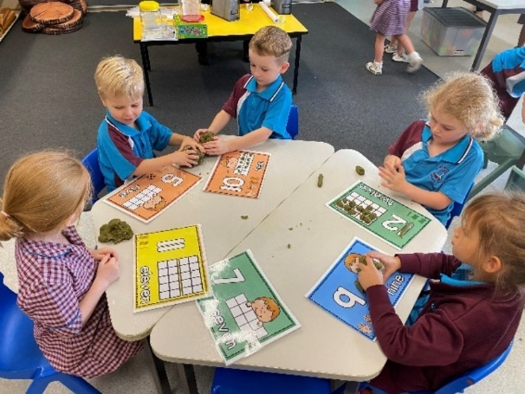
  - What to do if you arrive at school and your child gets upset and cries
Some children become upset despite the best preparation. If this happens to your child, please signal for support from the classroom Teacher or Education Assistant and then leave as quickly as possible. Students usually quickly settle once parents have left. If your child continues to be distressed, we will phone you and talk about strategies and approaches that we can use for next time. If children see parents outside the classroom it can impact their ability to calm down, so moving out of view is helpful.

If your child is coming with Before and After School Care, we will move through this process with your child.

What Your Child Needs to Bring Each Day
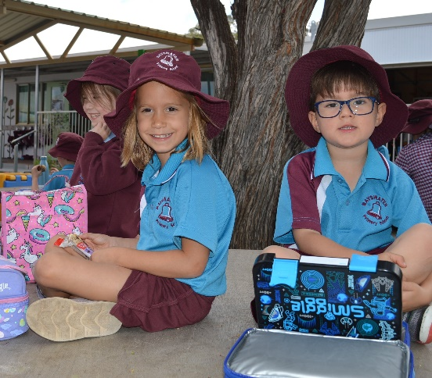
Each day your child will need;
- To be dressed in school uniform,
- A large school bag,
- Their crunch n sip (fruit or vegetables, cut up in a small container that your child will be able to open independently),
- A drink bottle of water,
- Their recess and lunch in a lunch box,
- A spare change of clothes- shirt, pants, a few pairs of underwear and socks,
- A broad brimmed hat, that is sun safe,
- Shoes that your child can take off and put on easily, we suggest velcro tabbed shoes,
- Please ensure that every item is clearly marked with your child’s full name. Please discourage your child from bringing toys and lollies to school.

Birthdays
To help celebrate your child’s birthday you may wish to provide small baked goods, or small individual treats for the class to share. Please consider any food allergies/requirements (no nuts) in your child’s class and ensure you provide an ingredient list.

Parent Roster
We value having families helping in our classroom. The roster for parent helpers will be displayed on the board outside the classroom from Term 2. All parent volunteers will need to sign a Parent Volunteer Declaration Form in the front office.

Reading
Reading to your child is one of the most impactful ways to support their development. It fosters a love for books and learning while enhancing language skills, vocabulary, and comprehension.

Engaging in shared reading creates valuable bonding moments, allowing you to connect with your child and discuss the text together. This interactive experience encourages critical thinking as they ask questions and express their thoughts about the story. We encourage all families to establish a routine of reading together to not only cultivate literacy skills but also instill a lifelong passion for reading.

Handwriting

Pre-writing Skills Development- Peggy Lego
At Bayswater we use the Peggy Lego program which is a systematic way to teaching prewriting patterns, which form the basis of all letters of the alphabet. Peggy Lego breaks down letters into seven pencil movements and then supports students to learn correct letter formation with these patterns’.

The program includes a story for each of the patterns, a gross motor activity, a sensory/tactile activity, a fine motor activity and then finally the writing activity.

The prewriting patterns include; Tall man, Sideways, Starts with a Click, Jack and Jill, Under the Gate and Over the Gate. When children have the correct motor pattern in place, it will allow them to then correctly form the letters of the alphabet as they learn them in the early years of school.
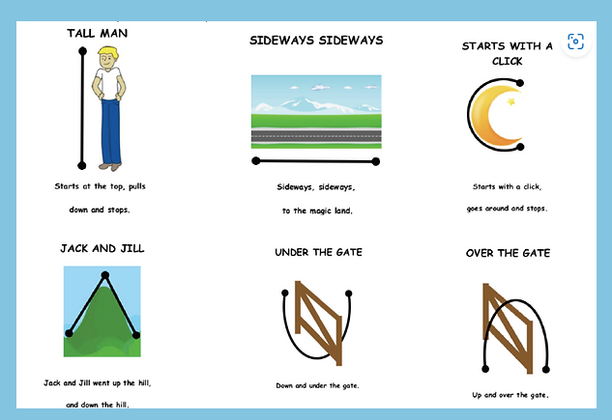

  - Name Writing
If you would like to encourage your child to practise writing their name at home, it would be helpful if they use a capital letter for the first letter of their name and then lower-case letters for the other letters. In Kindergarten we focus on lowercase letters. The style of handwriting taught at Bayswater Primary is the South Australian Cursive.
Aa | Bb | Cc | Dd | Ee | Ff | Gg | Hh | Ii
Jj | Kk | Ll | Mm | Nn | Oo | Pp | Qq | Rr
Ss | Tt | Uu | Vv | W | Xx | Yy | Zz
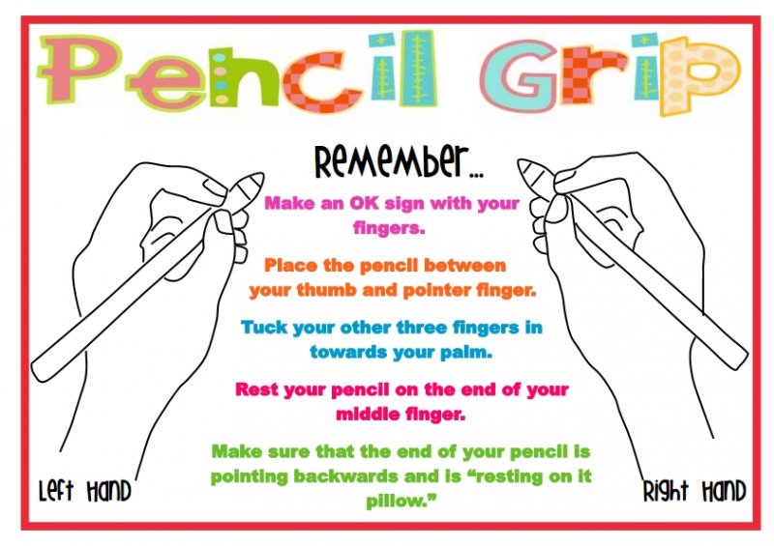

We look forward to supporting you and your child in 2026 and together experience a happy and rewarding Kindergarten year.

