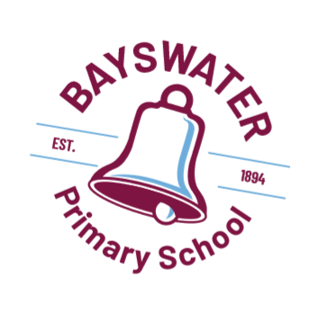
2023 Term Three Planner
Week | MONDAY | TUESDAY | WEDNESDSAY | THURSDAY | FRIDAY
Week 1 | 17/7  Students Resume School  Chess Club 3pm (wkly) | 18/7  PMI Muisc 3pm (wk1-10) | 19/7  Kindy Group – Green  Band Practice 7.40-8.40 (wkly)  MBA Sport 3pm (wkly) | 20/7  Newsletter  Senior Choir 7.50-8.40 (wkly)  PMI Music 3pm (wk1-10) | 21/7  Kindy Group – Blue  2024 Kindy Applications due
Week 2 | 24/7  Soccer X 3pm (wk 2-10)  P&C Mtg 7pm | 25/7  Young Engineers 3pm (wk 2-9) | 26/7  Kindy Group – Orange | 27/7 | 28/7  Kindy Group – Red  Assembly Rm 5 Yr 5  National Tree Planting Day
Week 3 | 31/7  Swimming Lessons  Pre-primary – Year 6 | 1/8  Swimming Lessons | 2/8  Kindy Group – Green  Swimming Lessons | 3/8  Swimming Lessons  Basketball 7.30-8.30am (wk3-10) | 4/8  Kindy Group – Blue  Swimming Lessons
Week 4 | 7/8  Swimming Lessons | 8/8  Swimming Lessons | 9/8  Kindy Group – Orange  Swimming Lessons  School Board Mtg 6pm | 10/8  Newsletter  Swimming Lessons | 11/8  Kindy Group - Red  Swimming Lessons
Week 5  Sci Week | 14/8  Water Corp Incursion | 15/8 | 16/8  Kindy Group – Green | 17/8 | 18/8  School Development Day (4) – No school for students
Week 6  CBCA  Book Week | 21/8 | 22/8 | 23/8  Kindy Group – Orange | 24/8  Rm 11, 15 & 5 Bayswater Library Visit (11-12pm, 1-2pm) | 25/8  Kindy Group – Red  Book Character Parade 9am
Week 7 | 28/8  P&C Mtg 7pm | 29/8 | 30/8  Kindy Group – Green  Faction Athletics Jumps & Throws | 31/8  Newsletter | 1/9  Kindy Group – Blue  Faction Athletics Carnival
Week 8 | 4/9  NAIDOC Day/week tbc | 5/9 | 6/9  Kindy Group – Orange  Mini K/PP Carnival 1.30pm  School Board Mtg 6pm | 7/9 | 8/9  Kindy Group - Red  Assembly Rm 9 Yr 3
Week 9 | 11/9 | 12/9 | 13/9  Kindy Group – Green | 14/9  R U OK? Day | 15/9  Kindy Group - Blue  Leadership Assembly
Week 10 | 18/9  Interschool Athletics Jumps & Throws TBC | 19/9 | 20/9  Kindy Group – Orange  Interschool Athletics Carnival TBC | 21/9  Newsletter | 22/9  Kindy Group – Red  Assembly Rm 13 Yr 1  Last Day of Term 3  Free Dress Day
Please note that additional dates and events will beaded throughout the Term, please se the newsletter, Facebook and email for updates.

