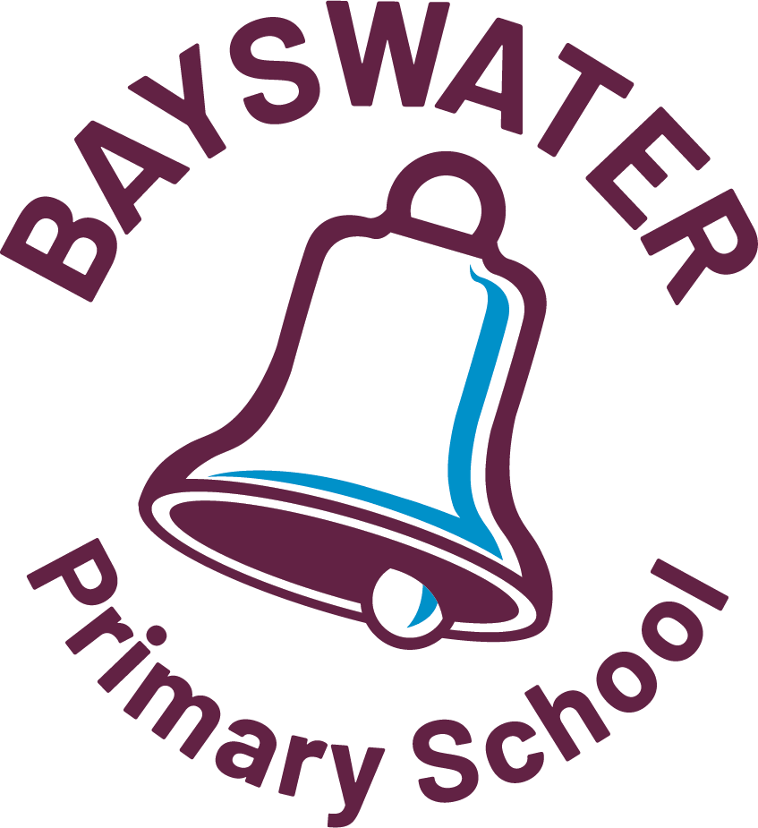
FORM 5 - MILD TO MODERATE ALLERGY MANAGEMENT & EMERGENCY RESPONSE PLAN

Name: ______________________________________ Date of Birth: ________________________
Year: __________ Form: ______________ Teacher: _______________________________
Section A – Student Health Care Planning
To be completed by parent/carer - (Please list specific allergens and most recent reactions in the table below).
My child is allergic to: |  |  |  | For each allergen provide specific information (e.g. peanuts – even small quantities) |  |  | Describe your child’s most recent symptoms and date of reaction to the allergen (e.g. hay fever, hives, eczema).
Peanuts
Tree Nuts
Milk
Eggs
Soy Products
Wheat Products
Shellfish
Fish
Insect Stings or Bites (Please specify insect(s) if known)
Medication (Please specify which medication(s) if known)
Other/Unknown(Please specify food(s) if known)
Section B - Daily Management
List strategies that would minimise the risk of exposure to known allergens.
Section C – Medication Instructions (Note: Medication must be provided by parents/carers)
 | medication 1 |  |  |  |  | medication 2 |  |  | medication 3
Name of medication
Expiry date
Dose/frequency – may be as per the pharmacist’s label
Duration (dates) | From :  To: |  |  |  |  | From :  To:
Route of administration
Administration  Tick appropriate box | By self  Requires assistance |  |  |  |  | By self  Requires assistance |  |  | By self  Requires assistance
Storage instructions  Tick appropriate box(es) | Stored at school  Kept and managed by self  Refrigerate  Keep out of sunlight  Other |  |  |  |  | Stored at school  Kept and managed by self  Refrigerate  Keep out of sunlight  Other |  |  | Stored at school  Kept and managed by self  Refrigerate  Keep out of sunlight  Other
Section D - Emergency Response
As per ASCIA action plan attached -This must be completed by your child’s medical practitioner. Go to the ASCIA website for Action Plans and further information: https://www.allergy.org.au/health-professionals
Section E – Authority to Act
This mild to moderate allergy management and emergency response plan authorises school staff to follow my/our advice and/or that of our medical practitioner. It is valid for one year or until I/we advise the school of a change in my/our child’s health care requirements.
Parent Signature:  Date: |  | Medical practitioner’s name (and Medical Practice if required)  Medical Practitioners Signature:  Provider Number: Date: |  |  |  |  |  |  |  | Review Date:
When completed, please attach to the Student Health Care Summary.
form 5 page 1 of 2

OFFICE USE ONLY
Date received: Date uploaded on SIS:
Is specific staff training required? Yes No : Type of training:
Training service provider:
Name of person/s to be trained: Date of training:
form 5 page 2 of 2

ASCIA Emergency Action Plans are regularly updated. To ensure you are using the most current documentation, go to the ASCIA website: https://www.allergy.org.au/health-professionals

